

**Southern River College**

**Task 3 Psychology ATAR**

**Extended Answer – in class**

Weighting: 6%

Time: 60 minutes

Lily is a Year 11 student trying to establish a good study routine early in the year. She studies in her bedroom but finds this quite boring so she usually has Netflix on in the background and because it’s very hot where Lily lives she always has the fan on when she is studying. One day, Lily invited one of her friends over to study with her in her room. Lily’s friend got quite annoyed at Lily and asked her to turn the fan off as it was too distracting. By the end of the year Lily had been studying for several hours every day, and her fan was feeling the strain. As a result of its prolonged use it began to shake profusely, and Lily became very frustrated as it was distracting her from her work.

* Define relevant terms
* Explain in terms of selected and divided attention how Lily could improve her study habits
* Explain why the fan does not distract Lily but does distract her friend
* Explain why the shaking fan began to distract Lily and describe the effect this will have on her study habits
* Include psychological evidence to support your response.

|  |  |  |
| --- | --- | --- |
| **Criteria** | **Possible mark** | **Mark** |
| **Definition** | **2** |  |
| * Defines and explains ‘attention’ (selected, divided, habituation, dishabituation) | 2 |  |
| * Provides a definition of ‘attention’ | 1 |  |
| **Selected and Divided Attention** | **3** |  |
| * Defines selected and divided attention * Explains how Lily is dividing her attention between studying and Netflix * Explains how Lily could use selective attention to improve her study habits | 3 |  |
| * Defines selected and divided attention * Describes how selected and divided attention are being used by Lily | 2 |  |
| * Identifies and briefly describes selected and divided attention | 1 |  |
| **Habituation** | **3** |  |
| * Defines habituation * Explains how Lily has habituated to the fan * Explain why Lily’s friend has not habituated to the fan | 3 |  |
| * Defines habituation * Describes how habituation has affected Lily and her friend | 2 |  |
| * Identifies and briefly describes habituation and how it relates to Lily or her friend | 1 |  |
| **Dishabituation** | **3** |  |
| * Defines dishabituation * Explains how and why lily has dishabituated to the fan and what effect this will have on her study | 3 |  |
| * Defines dishabituation * Describes why Lily is distracted by the fan | 2 |  |
| * Identifies and briefly describes dishabituation | 1 |  |
| **Use of psychological evidence – quantity** | **3** |  |
| Several statements are supported by relevant psychological evidence (e.g. name of researcher/theorist or example of a study) | 3 |  |
| One or two statements are supported by relevant psychological evidence (e.g. name of researcher/theorist or example of a study) | 1 – 2 |  |
| **Use of psychological evidence – quality** | **3** |  |
| One example of detailed relevant psychological evidence (e.g. 3-4 sentences about a specific research study and findings) – researchers, aim, method, results | 3 |  |
| One example of relevant psychological evidence, including some description | 2 |  |
| Psychological evidence consists of names/statements only without description (e.g. name of study, name of researcher) | 1 |  |
| **Communication** | **3** |  |
| Well-developed sentences and paragraphs and consistent use of appropriate psychological language and correct spelling, grammar and punctuation | 3 |  |
| Coherent response with adequate spelling, grammar, sentence structure and paragraph structure | 2 |  |
| Lack of paragraph/sentence structure or colloquial language or poor English expression or many spelling errors | 1 |  |
|  | **20** |  |

**Selective attention** refers to the ability to pay **attention** to a limited array of all available sensory information.

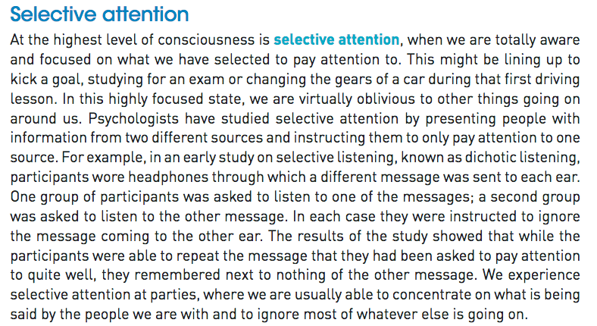

**Divided attention**: The ability to focus on two or more stimuli simultaneously

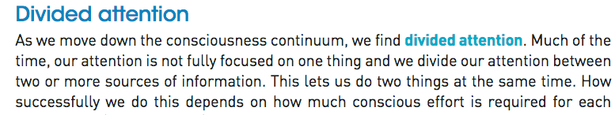

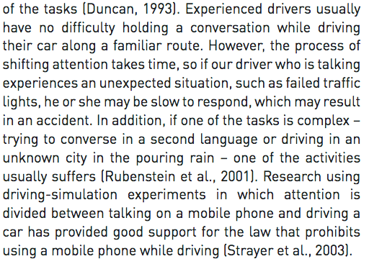

**Habituation** the diminishing of an innate response to a frequently repeated stimulus.

**Dishabituation:** is a form of recovered or restored behavioural response wherein the reaction towards a known stimulus is enhanced

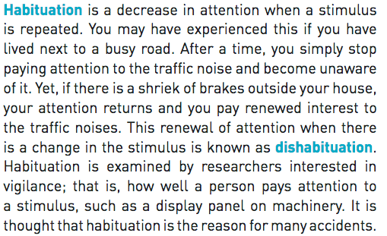

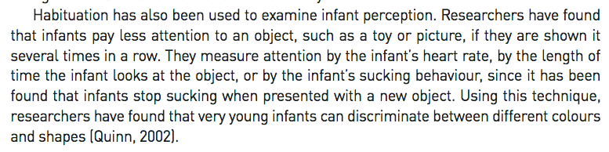

Lily has divided attention between Netflix and her studies

Lily became dishabituated to the fan, then becomes dishabituated to the fan as it begins to rattle. The initial stimulus of the fan has changed.

Improved study habits: get a new fan, turn the fan off, turn off Netflix

Psychological evidence

For selected attention

**Dichotic Listening Task (Cherry, 1953)**

* Participants were asked to listen to information that they could hear only from the one side and instructed to ignore the message coming into their other ear
* Results = participants were able to repeat the message they had been asked to pay attention to quite well but remembered nothing of the other message.
* selective attention

This happens to us a lot at parties etc. where we are able to concentrate on what one person is saying and ignore others

For Habituation

**Quinn, 2002**

* Habituation can be seen in infants (cute)
* Researchers have shown that infants pay less attention to an object such as a toy or a picture the more they are shown it.
* They measure attention by the infant’s heart rate, by the length of time the infant looks at the object or the infant’s sucking behaviour as it has been found that infants stop sucking when presented with a new object. (has been used to show infants know the difference between colours at a very young age)
* habituation in infants

For Divided Attention

**Rubenstein, 2001**

* Experienced drivers usually have no difficulty holding a conversation while driving their car long a familiar route.
* However, the process of shifting attention takes time, so if the driver who is talking experiences an unexpected situation such as failed traffic lights they may be slow to respond 🡪 accident
* In addition, if one of these tasks is complex e.g. talking in a 2nd language or driving in an unknown city in the rain – one of these activities usually suffers = problems when we divide our attention!